Smith Library
How to Insert Footnotes in Word: A Guide for Creating Footnotes According to Turabian 9th Edition manual

Turabian 9th Edition Requirements:
• Use 10-point Times New Roman font (unless otherwise instructed) (A.1.2)
• Single-space within each footnote entry (16.3.4)
• Leave a blank line (double space) between footnote entries (16.3.4)
• Indent first line of footnotes by ½ inch (five spaces) (16.3.4)
______________________________________________________________________________
Step 1: Click on the location in the text of your document where you would like to insert the number for the footnote. Make sure the flashing cursor is where you would like the footnote reference to be added.
______________________________________________________________________________
Step 2: Click on “References” in the menu at the top of Microsoft Word.
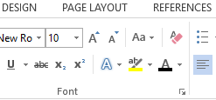

Step 3:
Then, select “Insert Footnote.” The keyboard shortcut of Alt+Ctrl+F will also allow you to insert the footnote.
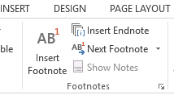
____________________________________________________________________________
Microsoft Word will add a number entry at that location and then focus the cursor to the bottom of the page for the footnotes where the same number has been added. Numbers for footnotes will automatically start with “1” and are numbered incrementally from there. Footnotes are automatically added on the same page as the footnote reference.
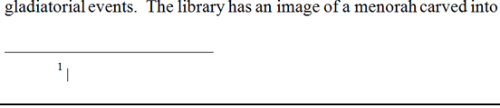

Step 4: Type the Turabian reference for the footnote.

Step 5:
For proper Turabian formatting, footnotes should be indented by ½ inch (five spaces) (p. 156). This isn’t the default setting for Microsoft Word, so it is important to make sure this is done for each footnote entry. Highlight the footnote (or all of the footnotes on your page) with your mouse and select “Paragraph”.

Then, choose a first line indent of 0.5” as shown below.
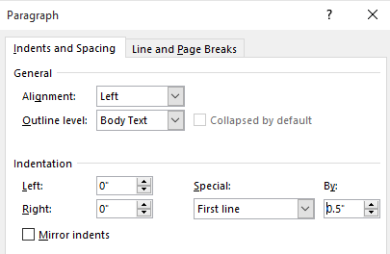
Now that the footnote has been inserted, you may click back into the main text of the document and continue.
- To insert a subsequent footnote, press CTRL+ALT+F.
- To delete a footnote, highlight the footnote’s number in your document and press the Delete key. If you delete a footnote, MS Word will renumber the notes in a new order.

